# Assignment. 9

**Title:** Case **Study**

**Aim:** Using conceptsof Object Oriented programming develop solutionfor any one application

1. Banking solution contains followingoperations such as 1. Create an account 2.Deposit money 3.Withdraw money 4. Honor daily withdrawal limit 5. Check the balance 6. Display Account information.
2. Inventory management contains followingoperations such as List of all products 2.

Display individual

product information 3. Purchase 4. Shipping 5.Balance stock 6. Loss and Profit calculation.

**Objectives: To implement real time context. Sample Code:**

Create following classes and Methods

class Account : Set balance(),Getbalance(),setAccount type(),getaccounttype Class Bank: creatAccount(),withdrawAmount(),depositAmount(),displayinfo()

Class customer: getCustomerName(),setCustomerName(),getcustomerAge(),setCustomerAge() Class saving account: setMinimumBalance (),withdraw()

**Input:**

Enter your name: Sai Enter your age: 15

Minimum age should be 18 to create an account. Please enter valid age: 21

Enter your account Id: 1

Enter your account type: savings Enter balance: 10000

Enter minimum balance: 1000

**Output :**

1. Create Account 2.Display Account 3.Check Balance 4.Deposit Amount 5.Withdraw Amount Enter your choice: 1 Enter your name: Sai Enter your age: 15

Minimum age should be 18 to create an account. Please enter valid age: 21

Enter your account Id: 1

Enter your account type: savings Enter balance: 10000

Enter minimum balance: 1000

Do you want to perform more actions? (yes/no): yes 1.Create Account

1. Display Account 3.Check Balance 4.Deposit Amount 5.Withdraw Amount Enter your choice: 2

Welcome Sai Pande! Following are your account details: Age :21

Account Id: 1

Account Type: savings Balance: 10000.0

Minimum balance: 1000.0

Do you want to perform more actions? (yes/no): yes 1.Create Account

2.Display Account 3.Check Balance 4.Deposit Amount 5.Withdraw Amount Enter your choice: 3 Balance is: 10000.0

Do you want to perform more actions? (yes/no): yes 1.Create Account

2.Display Account 3.Check Balance 4.Deposit Amount 5.Withdraw Amount Enter your choice: 4

Enter the amount you want to deposit: 20000 Amount deposited successfully. Balance is: 30000.0 Do you want to perform more actions? (yes/no): yes 1.Create Account

2.Display Account 3.Check Balance 4.Deposit Amount 5.Withdraw Amount Enter your choice: 5

Enter the amount you want to withdraw: 30000

Withdrawal failed. Maximum limit of withdrawal in one transaction is Rs.20000. Do you want to perform more actions? (yes/no): yes

1. Create Account 2.Display Account 3.Check Balance 4.Deposit Amount 5.Withdraw Amount Enter your choice: 5

Enter the amount you want to withdraw: 15000 Withdrawal successful. Balance is: 15000.0

Frequently Ask Question:

* 1. List the features which are used for application development
  2. How the polymorphism applied
  3. Can we apply interface or abstract class in given case study ? How.
  4. Did the application takes care of garbage collection
  5. Have you applied user defined exceptions in given case study ? Give examples .
  6. How many objects are created and how they are stored in memor

ALGORITHM

CODE:

import java.util.Scanner;

abstract class Car_Factory{

String company,cn, col;

double budget;

abstract void getprice(double price);

abstract void detail(String company_nane, String car_name, String co);

abstract void access ();

void input (){

Scanner sc =new Scanner (System.in);

System.out.print("Company Name : ");

company = sc.next();

System.out.print("Car: ");

cn=sc.next();

System.out.print("Budget Planned (in lakhs): ");

budget = sc.nextDouble();

System.out.print ("Enter Color of Car : ");

col=sc.next();

}

void display(Car_Factory c2){

c2.getprice(budget);

c2.detail(company,cn,col);

c2.access();

}

}

class Hatchback extends Car_Factory{

String rep;

public void getprice(double price){

if(price<2)

System.out.println("your buget is insufficient, plz increase your Budget");

else if(price>2&&price<5)

rep = "No";

else

rep = "Yes";

}

public void detail(String company_name, String car_name, String Color) {

System.out.println("\n********");

System.out.println("Company: "+company_name);

System.out.println("Name of Car : "+car_name);

System.out.println("Color : "+ Color);

System.out.println("Fule Type : Petrol");

System.out.println("Gears : Manual");

}

public void access(){

System.out.println("Type of wheels : Alloy Wheels");

System.out.println("Airbags : "+rep);

System.out.println("Back Wiper : "+rep);

System.out.println("Side Mirror : Two");

System.out.println("Touch Screen Music Player : "+rep);

}

}

class Sedan extends Car_Factory{

String rep;

public void getprice(double price){

if(price<2)

System.out.println("your buget is insufficient, plz increase your Budget");

else if(price>6&&price<10)

rep = "No";

else

rep = "Yes";

}

public void detail(String company_name, String car_name, String Col) {

System.out.println("\n********");

System.out.println("Company: "+company_name);

System.out.println("Name of Car : "+car_name);

System.out.println("Color : "+ Col);

System.out.println("Fule Type : Petrol/Diesel");

System.out.println("Gears :Automatic/ Manual");

}

public void access(){

System.out.println("Type of wheels : Alloy Wheels");

System.out.println("Airbags : YES");

System.out.println("Back Wiper : YES");

System.out.println("Side Mirror : Two");

System.out.println("Touch Screen Music Player : YES");

System.out.println("Roof Window : "+rep);

}

}

class Luxuray extends Car_Factory{

String rep;

public void getprice(double price){

if(price<2)

System.out.println("your Budget is insufficient, pla increase your Budget");

else if(price>10&&price<14)

rep = "No";

else

rep = "Yes";

}

public void detail(String company_name, String car_name, String col) {

System.out.println("\n********");

System.out.println("Company: "+company_name);

System.out.println("Name of Car : "+car_name);

System.out.println("Color : "+ col);

System.out.println("Fule Type : Diesel");

System.out.println("Gears : Automatic");

}

public void access(){

System.out.println("Type of wheels : Alloy Wheels");

System.out.println("Airbags : YES");

System.out.println("Back Wiper : YES");

System.out.println("Side Mirror : Two");

System.out.println("Touch Screen Music Player : YES");

System.out.println("Panoramic Sun-Roof : YES");

System.out.println("Automative Garbage Cans : "+rep);

System.out.println("Automotive Air Freshenar : "+rep);

System.out.println("Button Start : "+rep);

}

}

public class Main{

public static void main(String[] args){

Scanner sc1 = new Scanner(System.in);

int ch;

Car_Factory c1;

do{

System.out.println("\n1. Hatchback \n2.Sedan Car \n3.Luxury Car \n4. EXIT");

System.out.println("Enter Your Choice : ");

ch = sc1.nextInt();

System.out.println();

switch(ch){

case 1:

c1 = new Hatchback();

c1.input();

c1.display(c1);

break;

case 2:

c1 = new Sedan();

c1.input();

c1.display(c1);

break;

case 3:

c1 = new Luxuray();

c1.input();

c1.display(c1);

break;

case 4:

System.out.println("\nThank You ");

break;

default:

System.out.println("INVALID CHOICE !!");

break;

}

}while(ch!=4);

}

}

OUTPUT:

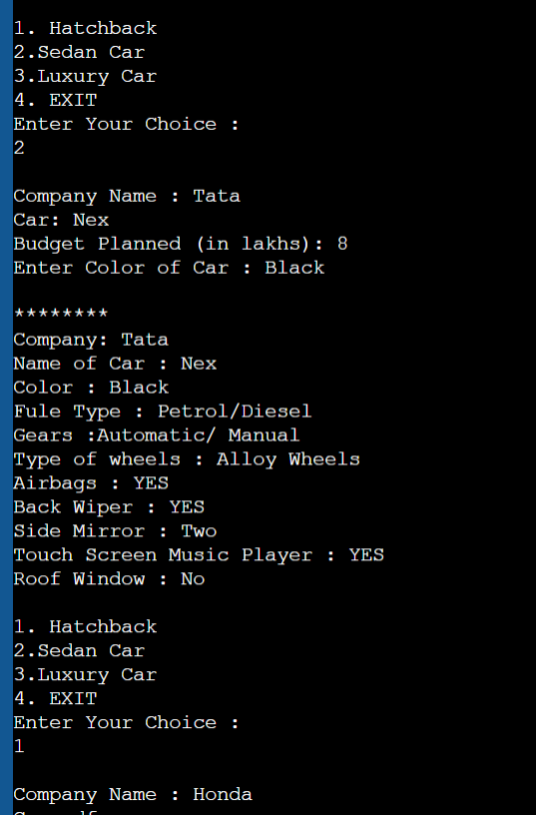

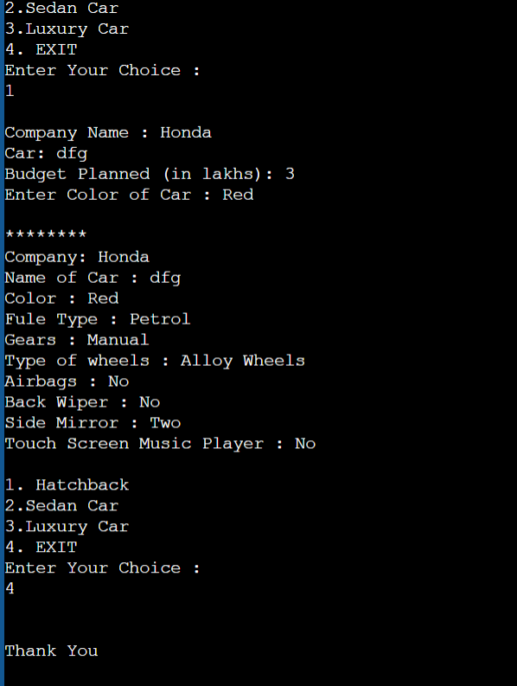

CONCLUSION

IN THIS ASSIGNMENT WE HAVE SUCCESSFULLY LEARNED THE CONCEPT OF OOP IN JAVA.